

**COLLEGE OF ARTS AND SCIENCES**

**SCHOOL OF COMPUTING (SOC)**

C:\Users\yeong\AppData\Local\Temp\ksohtml\wpsA9A.tmp.pngC:\Users\yeong\AppData\Local\Temp\ksohtml\wpsA9B.tmp.png

**STIW2044 MOBILE PROGRAMMING**

**SEMESTER A182 SESSION 2018/2019**

C:\Users\yeong\AppData\Local\Temp\ksohtml\wpsA9C.tmp.pngC:\Users\yeong\AppData\Local\Temp\ksohtml\wpsA9D.tmp.png

**Lab Assignment 1**

**PREPARED BY:**

**YEONG SHYH HAW(254772)**

**PREPARED FOR:**

**MR. AHMAD HANIS BIN MOHD SHABLI**

**SUBMITTION DATE:**

**24 FEBRUARY 2019**

**Java file -MAIN ACTIVITY**

**package** com.example.volumeunitconverter;  
  
**import** android.content.DialogInterface;  
**import** android.support.v7.app.AlertDialog;  
**import** android.support.v7.app.AppCompatActivity;  
**import** android.os.Bundle;  
**import** android.view.View;  
**import** android.widget.Button;  
**import** android.widget.EditText;  
**import** android.widget.RadioButton;  
**import** android.widget.RadioGroup;  
**import** android.widget.TextView;  
**import** android.widget.Toast;  
  
**public class** MainActivity **extends** AppCompatActivity {  
 **double result**;  
 EditText **Value**;  
 RadioGroup **converter**;  
 RadioButton **RadioButton**;  
 TextView **viewResult**;  
 RadioButton **rb1**, **rb2**, **rb3**, **rb4**;  
 Button **reset**;  
  
 @Override  
 **protected void** onCreate(Bundle savedInstanceState) {  
 **super**.onCreate(savedInstanceState);  
 setContentView(R.layout.***activity_main***);  
 **Value** = (EditText) findViewById(R.id.***value***);  
 **converter** = (RadioGroup) findViewById(R.id.***LitersConverter***);  
 **viewResult** = (TextView) findViewById(R.id.***viewResult***);  
 **rb1** = (RadioButton) findViewById(R.id.***RB1***);  
 **rb2** = (RadioButton) findViewById(R.id.***RB2***);  
 **rb3** = (RadioButton) findViewById(R.id.***RB3***);  
 **rb4** = (RadioButton) findViewById(R.id.***RB4***);  
 **final** Button reset = (Button) findViewById(R.id.***resetBTN***);  
  
  
 Button convert = findViewById(R.id.***convertBTN***);  
 convert.setOnClickListener(**new** View.OnClickListener() {  
  
 @Override  
 **public void** onClick(View v) {  
 **double** value = Double.*parseDouble*(**Value**.getText().toString());  
  
 **if** (**rb1**.isChecked()) {  
 **result** = value * 33.824;  
 } **else if** (**rb2**.isChecked())  
 **result** = value * 1.0570;  
 **else if** (**rb3**.isChecked())  
 **result** = value * 0.2642;  
 **else if** (**rb4**.isChecked())  
 **result** = value * 0.2200;  
 **else  
 viewResult**.setText(**"pls choose the unit type"**);  
  
 **viewResult**.setText(**""**+**result**);  
  
 }  
  
  
 });  
  
  
 reset.setOnClickListener(**new** View.OnClickListener() {  
 @Override  
 **public void** onClick(View v) {  
 **Value**.setText(**" "**);  
 **viewResult**.setText(**" "**);  
 **converter**.clearCheck();  
 }  
 });  
 String result = **" "**;  
  
 result+= (**rb1**.isChecked())?**"LIters To Fluid Ounces is selected"**:(**rb2**.isChecked())?**"Liters To Quarts is selected"**:  
 (**rb3**.isChecked())?**"Liters to Gallons is selected"**:(**rb4**.isChecked())?**"Liters to Gallons is selected"**: **""**;  
 Toast.*makeText*(getApplicationContext(), result, Toast.***LENGTH_SHORT***).show();  
  
  
 }  
}  
  
  
  
**ACTIVITY_MAIN XML**  
  
*<?***xml version="1.0" encoding="utf-8"***?>*<**ScrollView xmlns:android="http://schemas.android.com/apk/res/android"  
 xmlns:app="http://schemas.android.com/apk/res-auto"  
 xmlns:tools="http://schemas.android.com/tools"  
 android:layout_width="match_parent"  
 android:layout_height="match_parent"  
 tools:context=".MainActivity"**>  
  
 <**LinearLayout  
 android:layout_width="match_parent"  
 android:layout_height="wrap_content"  
 android:orientation="vertical"**>  
  
 <**TextView  
 android:id="@+id/TextView"  
 android:layout_width="match_parent"  
 android:layout_height="wrap_content"  
 android:layout_gravity="center"  
 android:gravity="center"  
 android:text="Volume Units Converter "  
 android:textSize="26sp"** />  
  
 <**TextView  
 android:id="@+id/textView2"  
 android:layout_width="match_parent"  
 android:layout_height="wrap_content"  
 android:text="Enter a value : "  
 android:textSize="18sp"** />  
  
 <**EditText  
 android:id="@+id/value"  
 android:layout_width="match_parent"  
 android:layout_height="wrap_content"  
 android:ems="10"  
 android:hint="Please enter a number"  
 android:inputType="numberDecimal"** />  
  
 <**TextView  
 android:id="@+id/textView3"  
 android:layout_width="match_parent"  
 android:layout_height="wrap_content"  
 android:text="Convert from :"  
 android:textSize="18sp"** />  
  
 <**RadioGroup  
 android:id="@+id/LitersConverter"  
 android:layout_width="match_parent"  
 android:layout_height="match_parent"**>  
  
 <**RadioButton  
 android:id="@+id/RB1"  
 android:layout_width="wrap_content"  
 android:layout_height="wrap_content"  
 android:layout_weight="1"  
 android:text="LIters To Fluid Ounces"** />  
  
 <**RadioButton  
 android:id="@+id/RB2"  
 android:layout_width="wrap_content"  
 android:layout_height="wrap_content"  
 android:layout_weight="1"  
 android:text="Liters To Quarts"** />  
  
 <**RadioButton  
 android:id="@+id/RB3"  
 android:layout_width="wrap_content"  
 android:layout_height="wrap_content"  
 android:layout_weight="1"  
 android:text="Liters to Gallons"** />  
  
 <**RadioButton  
 android:id="@+id/RB4"  
 android:layout_width="wrap_content"  
 android:layout_height="wrap_content"  
 android:layout_weight="1"  
 android:text="Liters To Imperial Gallons"** />  
  
 <**TextView  
 android:id="@+id/Result"  
 android:layout_width="wrap_content"  
 android:layout_height="wrap_content"  
 android:layout_weight="1"  
 android:text="Result : "  
 android:textSize="18sp"** />  
  
 <**TextView  
 android:id="@+id/viewResult"  
 android:layout_width="wrap_content"  
 android:layout_height="wrap_content"  
 android:layout_weight="1"  
 android:textSize="18sp"** />  
  
 </**RadioGroup**>  
  
 <**LinearLayout  
 android:layout_width="match_parent"  
 android:layout_height="match_parent"  
 android:layout_weight="1"  
 android:orientation="horizontal"**>  
  
 <**Button  
 android:id="@+id/convertBTN"  
 android:layout_width="wrap_content"  
 android:layout_height="wrap_content"  
 android:layout_weight="1"  
 android:text="convert"** />  
  
 <**Button  
 android:id="@+id/resetBTN"  
 android:layout_width="wrap_content"  
 android:layout_height="wrap_content"  
 android:layout_weight="1"  
 android:text="reset"** />  
  
 </**LinearLayout**>  
  
 </**LinearLayout**>  
</**ScrollView**>

**LAYOUT BLUEPRINT**

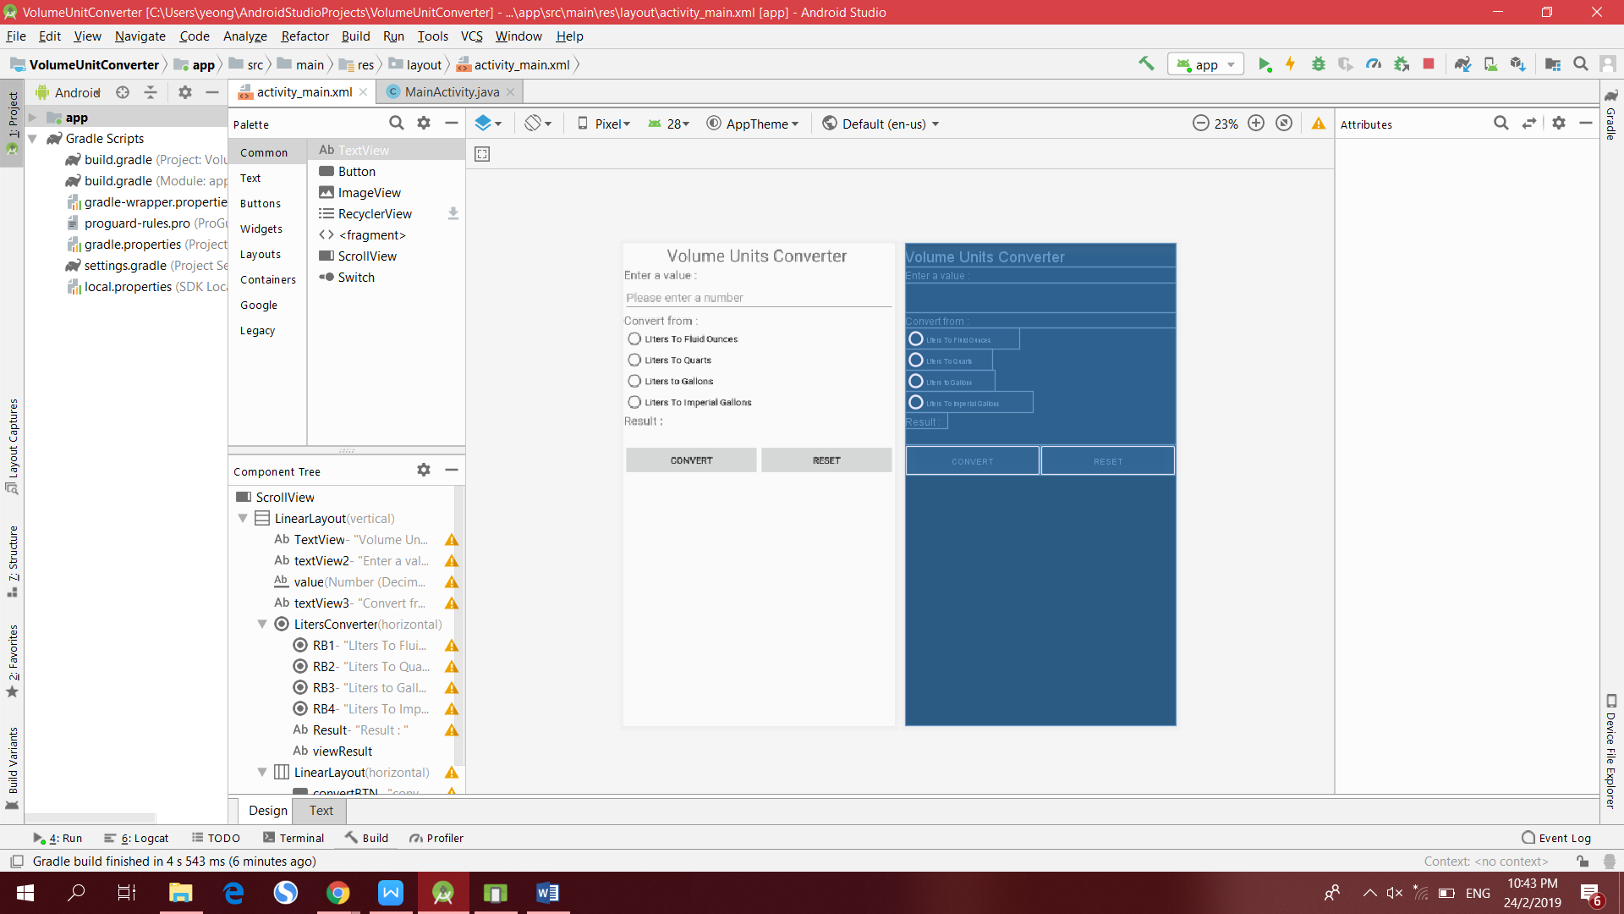

**Component Tree**

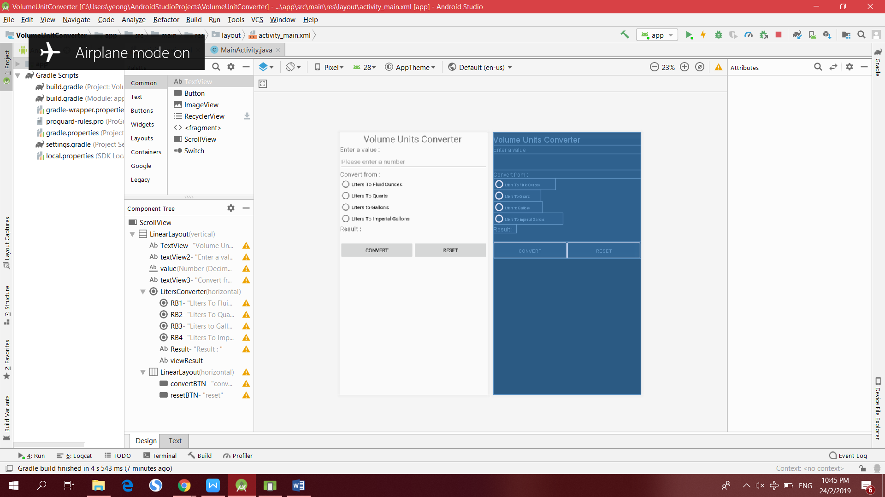

**APPLICATION INTERFACE**

**interface that before input**

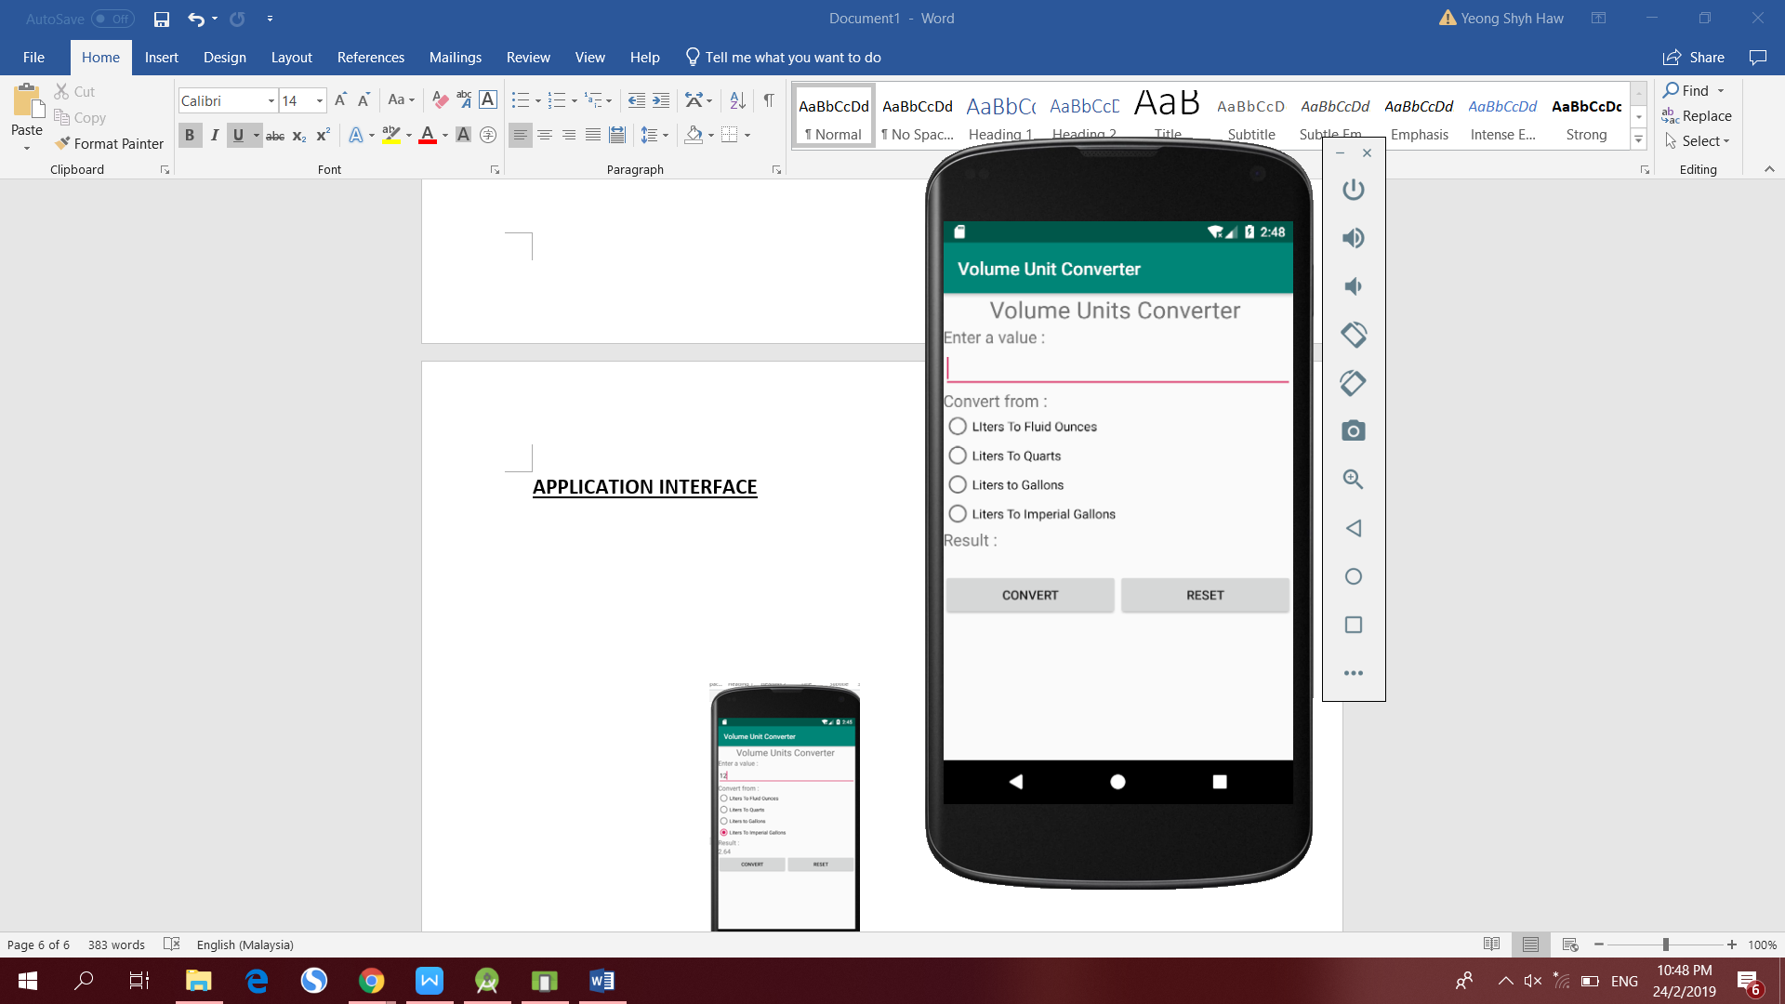

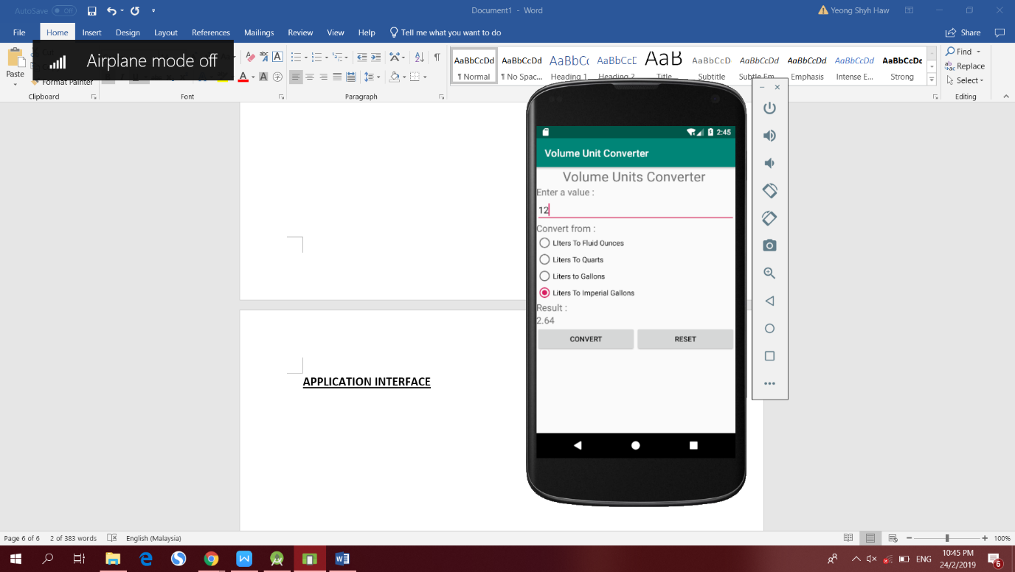**output**

